

**Dentist-Patient Data Model**

**First Draft**

Jayshil Jain

INFO6210 Database Management Database Design

Prof. Vincent Lattuada

Fall 2019

Table of Contents

Revision History 2

Overview 2

Object Model 3

Main Subject Areas 4

Patient 4

Dentist 4

Appointment 5

License 5

Dentist Confidential Details 5

Room 6

Dentist Assistant 6

Treatment Catalog 6

Collective Insurance 7

Allergies 7

Patient History 7

Patient Confidentiality 8

Patient Insurance 8

Supplies 8

Billing 9

Prescription 9

Medicine 9

Pharmacy 10

Outstanding Dues 10

Business Rules 10

In-scope Business Rules 10

Out of Scope Business Rules 13

# Revision History

|  |  |  |  |  |
| --- | --- | --- | --- | --- |
| Version | Changes Made | Date |  |  |
| 0 | Initial Document | 10/6/19 |  |  |
|  |  |  |  |  |
|  |  |  |  |  |

# 

# Overview

The general idea is to develop a data model for a dental clinic system. The main entities will include dentist, patient, appointment, room, bill, insurance and treatment. The patient will first need to book an appointment to visit the dentist. While booking, patient needs to register all the demographic details about them. The dentist will confirm the patient appointment. The scheduled appointment will be allocated a room that will have an address and a date and time. The patient needs to register all the confidential documents before the treatment begins. The patient then attends the appointment and receives the treatment from the dentist and his assistants. After the appointment a bill and prescription are generated by the dentist that will have all the details about the appointment. The Patient can use the prescription at a Pharmacy to get medicines that they need to take post the treatment. The doctor then collects the patient insurance policy and files for the claims and then notifies the patient about the outstanding dues. The patient receives the notification and can clear up all his/her balances with the dentist. The patient then makes the outstanding dues payment.

# Object Model

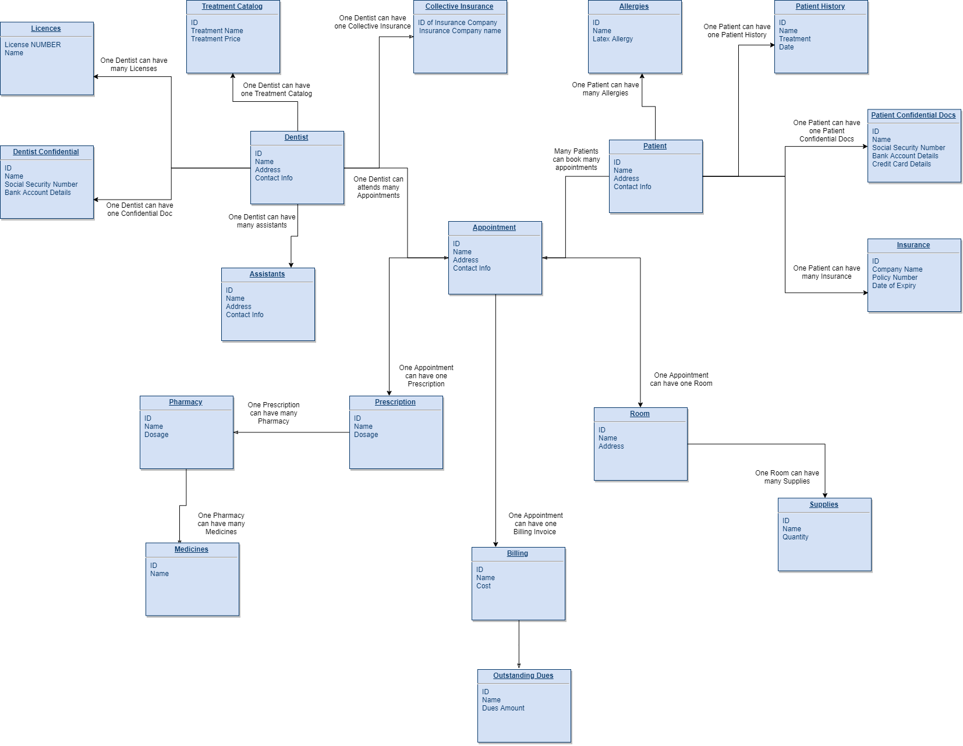

# Main Subject Areas

## Patient

Patient is a person who has specific dental issues and is visiting dental clinic by booking an appointment. Patient will have patient_name, patient_address, patient_contact_information and a Patient_id to give him/her a unique identity.

|  |  |  |  |  |  |
| --- | --- | --- | --- | --- | --- |
| Column | Datatype | Key/null | Additional | Example | Notes |
| patient_id | int | pknn | identity 1,1 | 111 | Auto increment by 1 to every new Patient Id |
| fname | char(25) | nn |  | Jeff |  |
| lname | char(25) | nn |  | Smith |  |
| Address 1 | varchar(100) | nn |  |  |  |
| Address 2 | varchar(100) | null |  |  | Address 2 can be empty |
| ZIP | char(5) | nn |  |  |  |
| Contact No. | varchar(10) |  |  |  |  |

## Dentist

Dentist is a person that is officially licensed to operate over the patients and has licensed by the dentistry system. He will have attributes like dentist_specialization, dentist_name, dentist_address, dentist_contact_information and a Dentist_Id to give him a unique identity.

|  |  |  |  |  |  |
| --- | --- | --- | --- | --- | --- |
| Column | Datatype | Key/null | Additional | Example | Notes |
| dentist_id | int | pknn | identity 1,1 | 111 | Auto increment by 1 to every new Dentist Id |
| fname | char(25) | nn |  | Jeff |  |
| lname | char(25) | nn |  | Smith |  |
| Address 1 | varchar(100) | nn |  |  |  |
| Address 2 | varchar(100) | null |  |  | Address 2 can be empty |
| ZIP | char(5) | nn |  |  |  |
| Contact No. | varchar(10) |  |  |  |  |

## Appointment

An appointment is defined as a time frame that patient books prior coming for a visit at dental clinic. Appointments once made can be cancelled and modified based on patient convenience. Appointment will have Appointment_id, Date, Patient_id, Dentist_id.

|  |  |  |  |  |
| --- | --- | --- | --- | --- |
| Column | Datatype | Key/null | Additional | Notes |
| appointment_id | int | pknn | identity 1,1 | Auto increment by 1 to every new Appointment Id |
| patient_id | int | fknn |  |  |
| dentist_id | int | fknn |  |  |
| Date Time | datetime | nn |  | Auto Generated upon the entry |
| Address | varchar(100) | null |  |  |
| ZIP | char(5) | nn |  |  |

## License

License is defined as a legal document owned by the dentist that is issued by the state using which a dentist can open a clinic and operate over his/her patients. License will have a License_Number and a License_Name. A dentist can have more than one licenses.

|  |  |  |  |  |
| --- | --- | --- | --- | --- |
| Column | Datatype | Key/null | Additional | Notes |
| dentist_id | int | pknn |  |  |
| License Number 1 | varchar(20) | nn |  | Licence Type 1 |
| License Name | varchar(20) | nn |  |  |
| License Number 2 | varchar(20) | null |  | Licence Type 2 |
| License Name 2 | varchar(20) | null |  |  |
| License Number 3 | varchar(20) | null |  | Licence Type 3 |
| License Name 3 | varchar(20) | null |  |  |

## Dentist Confidential Details

Dentist confidentiality contains the confidential documents that are needed to be hided for security reasons. It will contain dentist_id, Dentist SSN, Dentist Bank Account.

|  |  |  |  |  |
| --- | --- | --- | --- | --- |
| Column | Datatype | Key/null | Additional | Notes |
| dentist_id | int | fknn |  |  |
| Dentist SSN | char(9) | nn |  | SSN needs to be protected and will have limited access |
| Dentist Bank Account | varchar(20) | nn |  |  |

## Room

A room is defined as a place where the treatment action is performed by the doctor on patient. Room will have attributes like room_id, address, appointment_id and room_type where room type will describe facilities available in the room.

|  |  |  |  |  |  |
| --- | --- | --- | --- | --- | --- |
| Column | Datatype |  | Key/null | Additional | Notes |
| room_id | int |  | pknn | identity 1,1 | Auto increment by 1 to every new Room Id |
| Address | varchar(100) |  | nn |  |  |
| ZIP | char(5) |  | nn |  |  |

## Dentist Assistant

Dentist Assistant is a person who helps and assists dentist during the treatment. Dentist Assistant will have a assistant_id, fname, lname, Address and contact no.

|  |  |  |  |  |
| --- | --- | --- | --- | --- |
| Column | Datatype | Key/null | Additional | Notes |
| Assistant_id | int | pknn | identity 1,1 | Auto increment by 1 to every new Assistant Id |
| fname | char(25) | nn |  |  |
| lname | char(25) | nn |  |  |
| Address 1 | varchar(100) | nn |  |  |
| Address 2 | varchar(100) | null |  | Address 2 can be empty |
| ZIP | char(5) | nn |  |  |
| Contact No. | varchar(10) |  |  |  |

## Treatment Catalog

A treatment catalog will have all the details about the treatment with a Treatment_ID assigned to it every treatment will have one treatment_id and a specific price and name associated to it. The attributes included will be treatment_id, treatment_name, price, etc.

|  |  |  |  |  |
| --- | --- | --- | --- | --- |
| Column | Datatype | Key/null | Additional | Notes |
| treatment_id | int | pknn | identity 1,1 | Auto increment by 1 to every new treatment Id |
| treatment name | varchar(20) | nn |  |  |
| treatment price | double(20) | nn |  |  |

## Collective Insurance

The insurance company will contain the list of all insurance company and details about their policies. This will help dentist in filing for insurance claims. The attributes associated would be Insurance_company_id, name, invoice_id, claim_amount, amount_covered_by_insurance, covered_by_patient.

|  |  |  |  |  |
| --- | --- | --- | --- | --- |
| Column | Datatype | Key/null | Additional | Notes |
| insurance_company_id | int | pknn | identity 1,1 | Auto increment by 1 to every new insurance company Id |
| insurance_company_name | varchar(20) | nn |  |  |

## Allergies

The allergies will keep a track of all the allergies that a patient has before starting the treatment so that he/she can make sure he uses medication that suits the patient. Allergies will have attributes like patient_id, allergy_id, allergy_name, items_to_avoid, latex_allergy.

|  |  |  |  |  |
| --- | --- | --- | --- | --- |
| Column | Datatype | Key/null | Additional | Notes |
| allergy_id | int | pknn | identity 1,1 | Auto increment by 1 to every new allergy Id |
| allergy_name | varchar(20) | nn |  |  |
| latex_allergy | boolean | nn |  | Either true or false |

## Patient History

A patient history is a table that will store all the details of the patient’s past visits and all the treatments the patient has undergone. Patient history will help doctor to plan out the examinations he/she will be carrying. Patient history will have patient_id, treatment, date.

|  |  |  |  |  |
| --- | --- | --- | --- | --- |
| Column | Datatype | Key/null | Additional | Notes |
| patient_id | int | fknn |  |  |
| treatment_id | int | fknn |  |  |
| appointment_id | int | fknn |  |  |
| Date | datetime | nn |  | Date time will make each record unique |

## Patient Confidentiality

Patient confidentiality contains the confidential documents that are needed to be hided for security reasons. It will contain patient_id, Patient SSN, Patient Bank Account.

|  |  |  |  |  |
| --- | --- | --- | --- | --- |
| Column | Datatype | Key/null | Additional | Notes |
| patient_id | int | fknn |  |  |
| Patient SSN | char(9) | nn |  | SSN needs to be protected and will have limited access |
| Patient Bank Account | varchar(20) | null |  |  |
| Patient Credit Card Details | varchar(20) | null |  |  |

## Patient Insurance

Patient Insurance is defined as the insurance a patient is having with him/her that will cover up his dental expenses. A patient can have multiple insurance. The attributes will include patient_insurance_id, patient_id, insurance_validity, insurance_policy_details, insurance_company_name.

|  |  |  |  |
| --- | --- | --- | --- |
| Column | Datatype | Key/null | Notes |
| insurance_company_id | int | nn |  |
| insurance_company_name | varchar(20) | nn |  |
| patient_id | int | nn |  |
| policy number | varchar(20) | nn |  |
| Date of Expiry | datetime | nn |  |

## Supplies

Supplies is defined as the major medication supplies (like injections, painkiller, etc.) for which the patient is be billed separately. Supplies will have attributes like supply_id, appointment_id, room_id and date.

|  |  |  |  |  |
| --- | --- | --- | --- | --- |
| Column | Datatype | Key/null | Additional | Notes |
| supply_id | int | pknn | identity 1,1 | Auto increment by 1 to every new supply Id |
| supply_name | varchar(20) | nn |  |  |
| room_id | int | nn |  | The room associated will have supply details |
| quantity | int | null |  |  |

## Billing

The payment is the way patient makes payment to the dentist. There are multiple ways of payment and multiple modes of payment. Multiple ways may include upfront-payment, partial-payments and EMI payments. Modes of payment will include payments by card, cash, etc. Payment will include attributes like appointment_id, payment_mode, payment_way, total_cost_of_treatment, pending_amount.

|  |  |  |  |  |
| --- | --- | --- | --- | --- |
| Column | Datatype | Key/null | Additional | Notes |
| invoice_id | int | pknn | identity 1,1 | Auto increment by 1 to every new invoice Id |
| cost | double(10) | nn |  |  |
| appointment_id | int | fknn |  |  |

## Prescription

Prescription is defined as a document issued to the Patient after the treatment is done. This document will contain all the medicines and precautions to be taken by the patient. It will have prescription_id, precautions, etc.

|  |  |  |  |  |
| --- | --- | --- | --- | --- |
| Column | Datatype | Key/null | Additional | Notes |
| prescription_id | int | pknn | identity 1,1 | Auto increment by 1 to every new Prescription Id |
| appointment_id | int | fknn |  |  |
| medicine_id | int | fknn |  |  |
| precaution | varchar(20) | nn |  | This will keep track of the precaution patient needs to take care of |

## Medicine

Medicine is the drugs given to the Patient that will help in recovering from the Treatment. The medicine can only be given by a Pharmacy. The medicines will have a medicine id, medicine name.

|  |  |  |  |  |
| --- | --- | --- | --- | --- |
| Column | Datatype | Key/null | Additional | Notes |
| medicine_id | int | pknn | identity 1,1 | Auto increment by 1 to every new Medicine Id |
| prescription_id | int | fknn |  |  |
| medicine_name | int | nn |  |  |

## Pharmacy

Pharmacy is defined as a body that is legally authorized to give patients the medicines and drugs based on the prescription they have. No specific medicines can be given out by a pharmacy without a prescription letter from the Dentist. Pharmacy will pharmacy id, pharmacy name, address.

|  |  |  |  |  |
| --- | --- | --- | --- | --- |
| Column | Datatype | Key/null | Additional | Notes |
| pharmacy_id | int | pknn | identity 1,1 | Auto increment by 1 to every new Pharmacy Id |
| Pharmacy Name | varchar(100) | nn |  |  |
| Address | varchar(100) | nn |  |  |

## Outstanding Dues

The amount that is pending from the patient end after the insurance has covered its part of the cost. Every invoice will have an outstanding cost if patient wishes to use his/her insurance policy for the payment. The Outstanding dues will be deducted from the patient credit card.

|  |  |  |
| --- | --- | --- |
| Column | Datatype | Key/null |
| invoice_id | int | fknn |
| Outstanding dues amount | double(10) | null |

# Business Rules

## In-scope Business Rules

**IS01**

Associated Entities – Dentist, Patient

Patient books an appointment to see a Dentist.

**IS02**

Associated Entities – Appointment, Room

An Appointment once booked assigns a Room to it inside the Clinic at a specific day and time.

**IS03**

Associated Entities – Dentist, Treatment Catalog

A Dentist creates a Treatment Catalog that will have all the treatment details with a specific price assigned to it.

**IS04**

Associated Entities – Treatment Catalog, Billing

A billing invoice is generated once the patient is done with the complete treatment and the total cost is generated using the treatment catalog.

**IS05**

Associated Entities – Dentist, Patient Insurance

Patient has a Patient Insurance that he/she submits to the Dentist and the claims for the insurance is carried out by the Dentist.

**IS06**

Associated Entities – Dentist, Supplies

Dentist is responsible to maintain the supplies of the room and the clinic maintenance is also done by the dentist.

**IS07**

Associated Entities – Dentist, Patient History

Patient Test Reports are generated by the Dentist and is stored in as a part of the Patient History for future references.

**IS08**

Associated Entities – Outstanding Dues, Patient

Patient must make payment of the amount that was not covered by the insurance company and the mode of payment can be card or cash to the Dentist.

**IS09**

Associated Entities – Appointment, Room

Room is allocated once the Patient makes an appointment at the Clinic based on the room functionalities.

**IS10**

Associated Entities – Allergy

Patient has specific Allergies that he/she mentions that will be stored in a separate entity that will be displayed to the dentist prior to the appointment.

**IS11**

Associated Entities – Patient, Outstanding Dues

The patient needs to clear up the outstanding dues that is the amount that the insurance company did not cover.

**IS12**

Associated Entities – Dentist, Collective Insurance

Dentist creates an Insurance Company list where he/she lists all the insurance Companies with whom he/she needs to file a claim and then makes the claim for all the patients with same Insurance together.

**IS13**

Associated Entities – Dentist, Patient History

Patient history will be generated by the Dentist after every Patient visit and will store all the details about the treatment in it.

**IS14**

Associated Entities – Patient, Patient Confidential Documents

The Patient Confidential Documents will have all the details about the patient sensitive data like credit card details, SSN, etc.

**IS15**

Associated Entities – Prescription, Pharmacy

The prescription that will be generated will only be used at a pharmacy to get the medicines.

**IS16**

Associated Entities – Pharmacy, Medicines

The pharmacy cannot give out medicines that are not prescribed to the patient they need an official prescribed letter from a dentist to give out the medicines.

## Out of Scope Business Rules

**OS01**

The people who work at the Dentist Office and are not associated to the patient treatment like the Clerical Staff.

**OS02**

Capturing patient biometrics and storing it for security purposes.

**OS03**

Enrolling patients for a membership plan.

**OS04**

Maintaining an appointment history entity table.

**OS05**

Things to be avoided during a medication will not be given out from the dentist side.